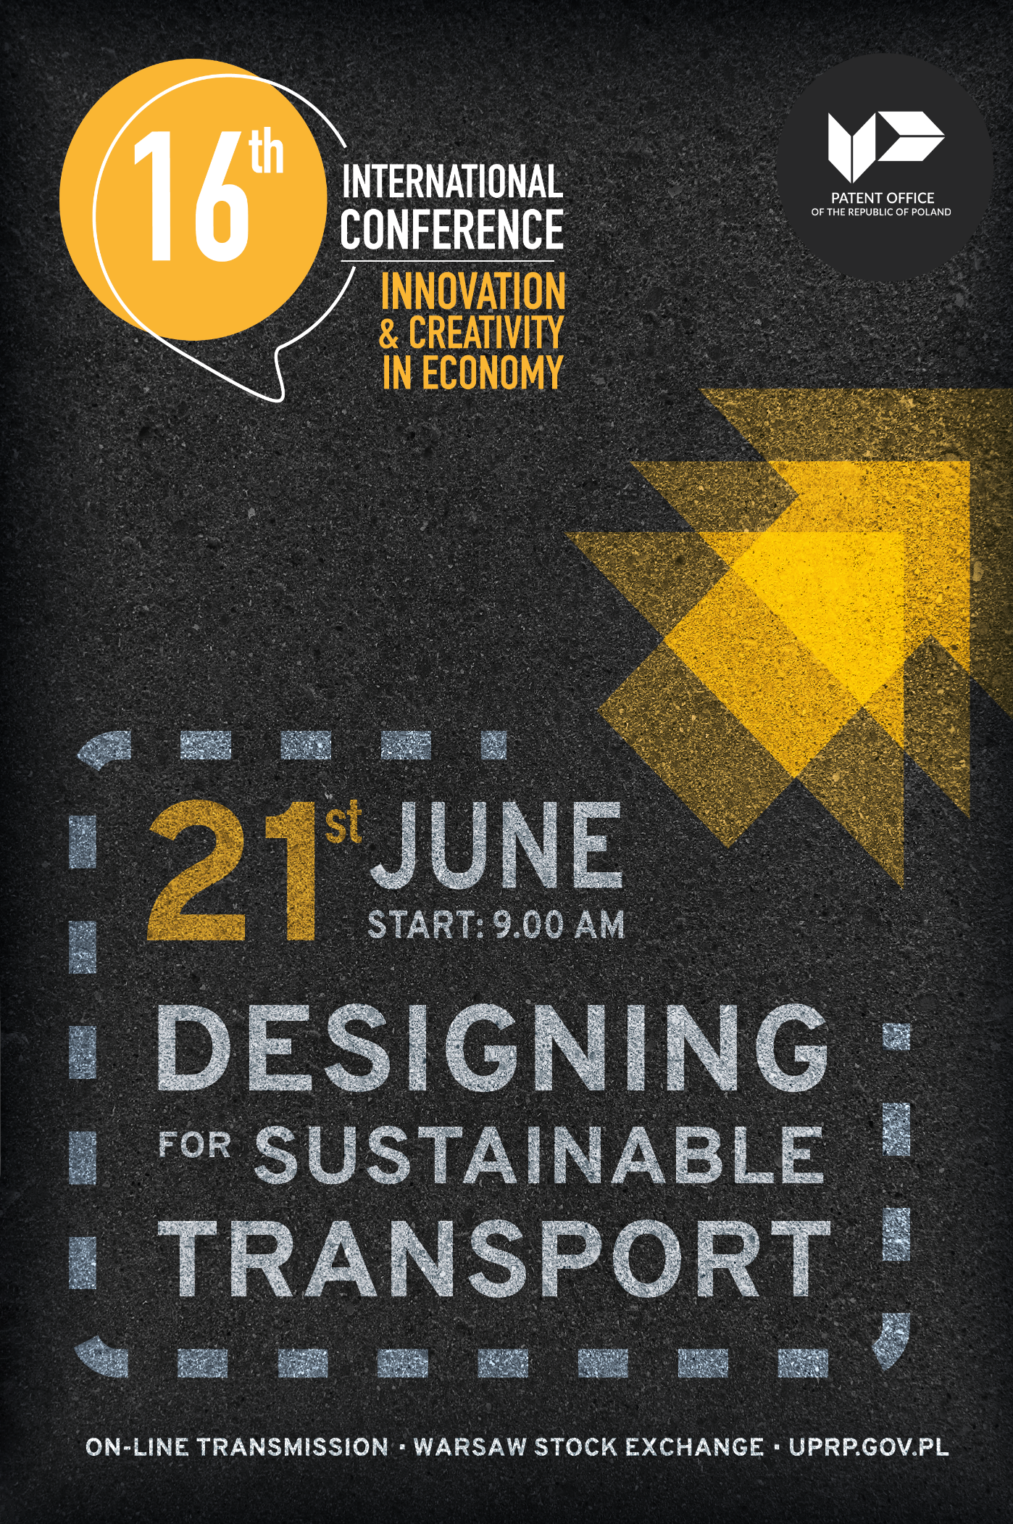

9:00 – 9:05 Introduction by the Conference moderator

Justyna Cięgotura, owner of JC Innovations in Science and Business, Incubation Manager in Poznań University of Life Sciences

9.05 – 9.25 Opening of the Conference

Edyta Demby-Siwek, President of the Patent Office of the Republic of Poland
Piotr Zabadała, Deputy Director of Innovation and Industrial Policy Department, Ministry of Economic Development and Technology

9.25 – 9.40 Opening addresses

Daren Tang, Director General, World Intellectual Property Organization
Christian Archambeau, Executive Director, European Union Intellectual Property Office

9.40 – 10.00 Special addresses

Edyta Demby-Siwek, President of the Patent Office of the Republic of Poland

10.00 – 11.00 Discussion

TRANSPORT AND CLIMATE CHALLENGES
Dawid Cycoń, CEO, founder of ML System S.A
Karolina Dulęmba, Advisor, Department of Energy Transformation, National Fund for Environmental Protection and Water Management
Weronika Czaplewska, Co-founder and Vice-President of Envirly

11.00 – 11.15 Conversation

Bartosz Piotrowski, Professor in the Faculty of Design, Fine Arts Academy
in Warsaw

11.15 – 11.45 Break

11.45 – 12.45 Discussion

USE OF INNOVATIVE TECHNOLOGIES TO IMPROVE THE MOVEMENT OF PEOPLE AND THE DELIVERY OF GOODS AND SERVICES
Sebastian Anioł, Director in Innovation Department, InPost
Justyna Świeboda, President, Polish Institute of Road Transport
Bartosz Dziugieł, Project Manager of ASSURED-UAM, Łukasiewicz Research Network – Institute of Aviation
Anna Maria Sobczak, Attorney-at-law, RPMS Staniszewski & Partners Law Firm

12.45– 13.00 Address

Yi Wang, Head, Hague Development and Promotion Section, The Hague Registry, Brands and Designs Sector, World Intellectual Property Organization

13.00 – 13.15 Address

PROTECTION OF DESIGN IN INNOVATIVE AND SUSTAINABLE TRANSPORT – PERSPECTIVE OF THE EUROPEAN UNION INTELLECTUAL PROPERTY OFFICE
Monika Tomczyńska, Examiner, Operational Department, European Union Intellectual Property Office

13.15 – 14.15 Lunch

14.15 – 14.45 Conversation

LUBLIN METROPOLITAN STATION – A NEW QUALITY OF TRAVELLING AROUND THE CITY AND THE REGION
Magdalena Federowicz-Boule, Architect, President and Creative Pirector, Tremend
Grzegorz Malec, Director, Public Transport Authority in Lublin

14.45 – 15.45 Discussion

MOBILITY IN THE CITIES OF THE FUTURE
Ewelina Gawell, Assistant Professor in the Department of Architectural and Urban Design, Faculty of Architecture, Warsaw University of Technology
Adam Jędrzejewski, Founder and President of the Mobile City Association
Marek Stawiński, Founder and President of NaviParking
Mariusz Wszołek, Communicology Expert, Professor in the Department of Graphic Design, University of Social Sciences and Humanities (SWPS)
in Wrocław
Anna Sokołowska-Ławniczak, Patent Attorney, Partner, Traple Konarski Podrecki and Partners Law Firm

15.45 – 15.55 Summary and closing of the Conference

ORGANIZER

CO- ORGANIZER

CONTENT PARTNER

